
https://atlas.cid.harvard.edu/

Optimal Industry Development Strategy Using Economic and Product Complexity

China

─
The Economic Complexity Lab - Columbia University
Haoxian Chen, Davepriyan Gunaratnam, Rohan Macherla, Ajit Akole, Shomik Ghose, Alex Wei-Liang Ku, Sannidhya Modi, Xilin Wang, Alexandra Garcia, Kelly Mi, Alex Chung, Margarita Demkina
Optimal Industry Development Strategy for China

0. Executive Summary

In this report, we aim to uncover the economic path China went through during the period from 2013 to 2018. We include an additional analysis regarding the impact of COVID-19 on the country’s development in 2021. Specifically, we dive into the topic through a macroeconomic overview of China from the perspective of Gross Domestic Product (GDP) and Economic Complexity Index (ECI), which reflect countries’ production capability and production structure, respectively. We find that from 2013 to 2018, China demonstrated a surprising level of economic growth with an annual GDP growth rate of 8.2%, concurrent with a stable economic complexity as compared with other major Asian or emerging economies in the world. Average annual GDP growth decreased to 7.87% between 2019 to 2021, and economic complexity decreased, again in line with other major developed economies.

The progress made during the period, we believe, can be largely explained through analysis of the economic and product complexity structure of China on the industry group level. The product classification system we adopt allows us to measure the realized industry development for various industry groups and to observe that China strategically invested in developing High-complexity Products, Transportation, and Machinery and Construction industries during the period, while its Asian counterparts and emerging economies around the globe have adopted much more conservative growth paths. Regarding the post-COVID decline in economic complexity coupled with a higher GDP as observed in 2021, we determine that China prioritized many different industries but failed to focus on the pertinent ones that support ECI growth.

Based on our analysis of the opportunity gain and a sensitivity analysis of major industry groups from 2013-2018, China can further its gains by staying optimal with its current industry structure and there is no immediate need of reform because no industry has a positive opportunity gain at its current stage. We further note that China already has a well-matched development strategy that indicates a high level of fitness with the strategy calculated on a complexity level, having an adjusted R-square of around 16.8%. However, in 2021, adjusted R-square is 4.5% as the difference between realized industry development and potential opportunity gain in the aforementioned and other industries is notably increased. Since a significant positive correlation exists between five-year GDP growth and the structural optimality index of an economy as we define and calculate, China adopted a favorable development plan as compared with other emerging economies both on a regional scale and on a global scale but still has potential to further leverage its economic gains through industrial structure optimization as suggested in the paper.

1. Report Overview

In this report, we aim to uncover the economic path China went through during the period from 2013 to 2018, and the impact of COVID-19 on its economic development as observed in 2021. Specifically, we dive into the topic through a macroeconomic overview of China from the perspective of Gross Domestic Product (GDP) and Economic Complexity Index (ECI), which reflect countries’ production capability and production structure, respectively. We then analyze the industrial framework and changes of China during the period based on quantitative measures such as Product Complexity Index (PCI) and Product Family Complexity Index (PfCI), followed by a detailed analysis of how such changes have matched with development strategies as quantitatively measured by opportunity gains on an industry-level. We conclude our report with macro-level results and predictions of China, as deduced from regression models we have established on a global scale, which takes into account countries’ stances in their product space.

2. Macroeconomic Results

2.1 GDP Ranking and Changes
As the 2nd largest economy in the world by GDP, China has a GDP of 9.6 trillion USD in 2013 and 13.6 trillion USD in 2018, exhibiting an extraordinary level of economic output. Figure 1 illustrates the time-series GDP results for major emerging economies from 1999-2018, and China ranks among its peers as a leading economy in terms of both GDP and GDP growth. The effect is prominent for the period from 2013 to 2018, during which China made an annual growth of 8.2% and more than doubled its GDP. This number is far above the annual growth rates of the other five leading emerging economies, which have a geometric average growth rate of 2.2% and an arithmetic average growth rate of 2.4%. Compared with more developed economies on a global scale, the annual growth rate of 8.2% is even more staggering since countries such as the United States have an annual GDP increase of merely around 4% during the period. The rapid economic growth, we believe, can be reflected through changes in ECI and PCI, and can be further explained by a well-chosen set of production strategies adopted by China from 2013 to 2018, which we will expand at the later stage of the report.
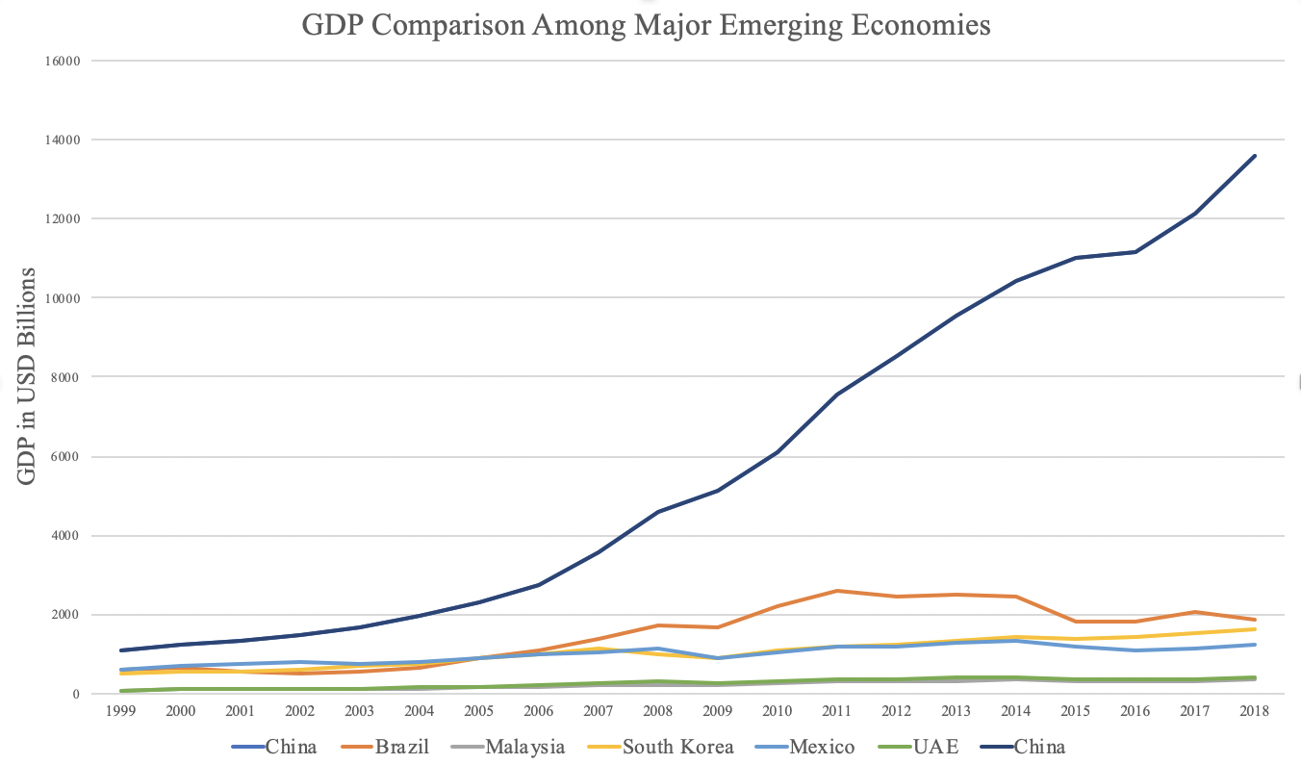
Figure 1: GDP Comparison Among Major Emerging Economies
Figure 2 illustrates the time-series GDP results in 2019-2021. Similar to the other countries, the China displayed stagnation in GDP in 2020 due to the economic implications of COVID-19, however, it increased in 2021. It displayed an impressive average annual growth rate of 7.87%, which was lower than 8.2% in 2018 but significantly higher than its peers Brazil (-3.87%), Malaysia (0.95%), South Korea (3.0%), and Mexico (1.5%).

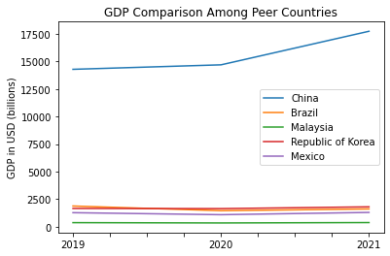
Figure 2: GDP Comparison Among Peer Countries (2019-2021)

2.2 ECI Ranking and Changes

The Economic Complexity Index (ECI), as defined by Ricardo Hausmann and Cesar Hidalgo in 2009 to explain the knowledge accumulated in a country's population, exhibits a similar pattern for China. As illustrated in Figure 3 below, China remains at a steady level in terms of its production capability from 2013 to 2018, as measured by ECI. This is in direct contrast to countries such as Brazil and UAE, which demonstrate both low ECI and a stagnant/decreasing ECI growth rate.

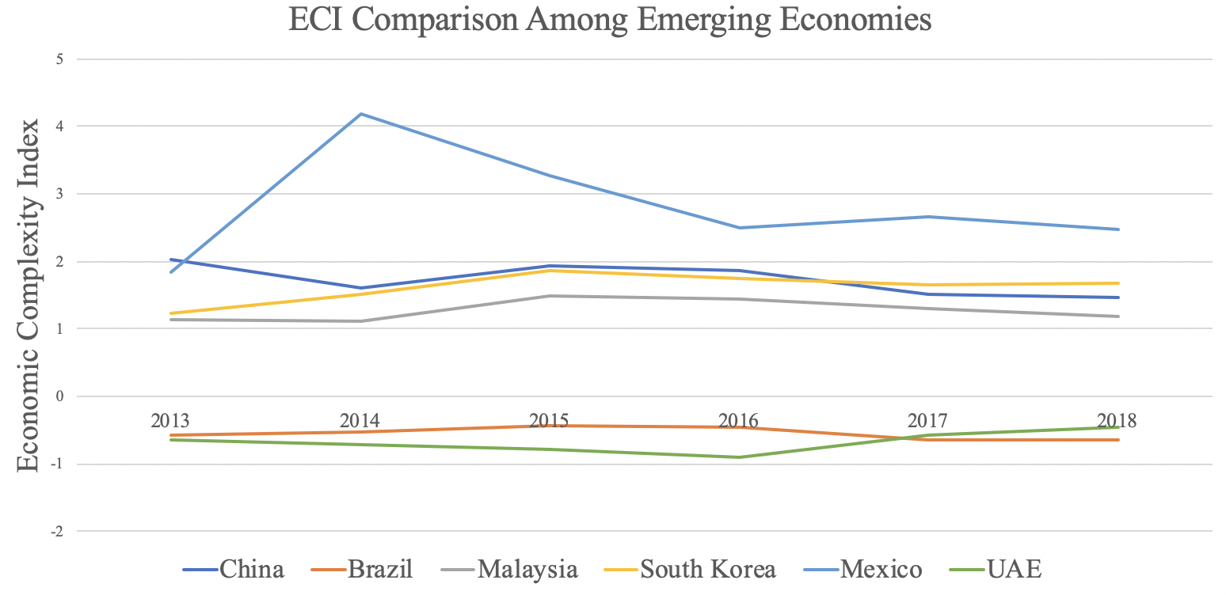
Figure 3: ECI Comparison (2013-2018)

However, as shown in Figure 4, China exhibits a decrease in production capability from 2019 to 2021. Its peers, excluding Brazil, also experienced comparable decreases in production capability over the period, as marked by a sharp decline in 2020.
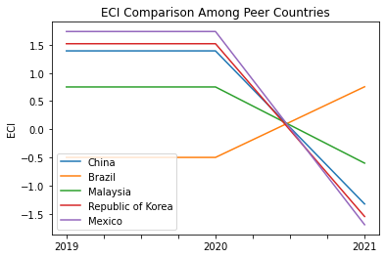
Figure 4: ECI Comparison (2019-2021)
Figure 5 offers a further comparison of GDP and ECI over the time span from 2013 to 2018 for China. Based on statistical analysis, ECI is a significant covariate for GDP with an adjusted R-square of 92.1%. However, we don’t observe a particularly strong correlation between GDP and ECI from 2013 to 2018, the period of our interest, where there is an adjusted R-square of 96.7% and ECI doesn’t seem to account for the variations in GDP of China. The results show that the dramatic GDP increase experienced by China during this period can be seen as independent from its fluctuating ECI, or the effectiveness of the country in developing a competitive product space that helps to accumulate complicated knowledge and technology. In order to provide a more concrete answer to why this has happened, we will dive into an analysis of China’s production structure and its product space designs in the next few chapters.

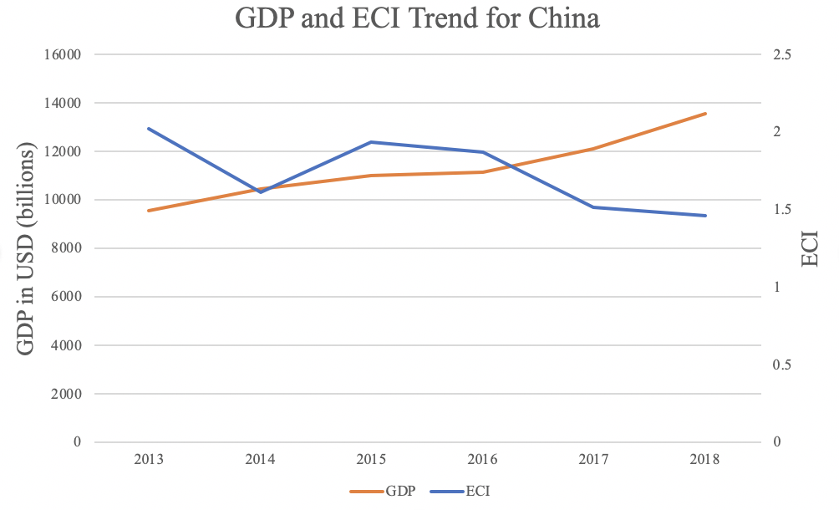
Figure 5: GDP and ECI of China (2013-2018)

Figure 6 compares GDP Growth and ECI between 2019 and 2021 for the UK. The decrease followed by a sharp increase in GDP growth during the period from 2019 to 2021 is paralleled by opposite changes in ECI. The COVID-19 pandemic in 2020 necessitated a prioritization of low complexity industries as demand for basic, essential products replaced that of higher-complexity, discretionary products. This explains the inconsistency in the relationship between GDP and ECI presented by the UK over this period.
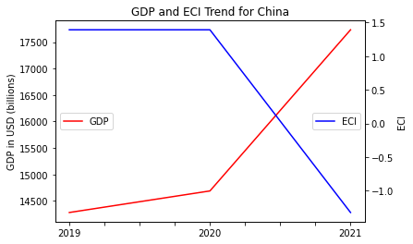
Figure 6: GDP and ECI of China (2019-2021)

Figure 6 compares GDP Growth and ECI between 2019 and 2021 for China. China’s ECI and GDP following the pandemic in 2020 exhibit opposite behavior. As ECI decreased, GDP continued to increase. The COVID-19 pandemic in 2020 necessitated a prioritization of low complexity industries as demand for basic, essential products replaced that of higher-complexity, discretionary products. This explains the inconsistency in the relationship between GDP and ECI presented by Chinaover this period.

3. Production Analysis

3.1 Product Categorization
Our main data source in this research is the UN Comtrade Website (https://comtrade.un.org), which provides us with valuable information on countries’ export values on an annual basis, including highly specific export data for more than 5000 categories of products. In order to have a holistic vision of the product space of a country, however, a level of categorization is required. Products in our data source are labelled from 010000-999999, with the first two-digits representing a general category to which the product belongs. Based on the 99 categories as extracted from the label, we further group the products into 18 most widely-accepted industries, as summarized in Table 1.

Note that the High-complexity Products industry group is not a distinct industry but rather an aggregated industry that encompasses the most complicated products from the most technologically-advanced industries (as measured by PCI). This industry serves as an indicator for us to quantitatively evaluate how well a country has performed in developing cutting-edge technologies and closing its technical gap with advanced economies, which has become a topic of wide concern today. Indeed, when we rank the 18 categories based on PfCI (an equivalent concept of PCI as calculated based on the 18 categorized product groups), the High-complexity Products industry has the highest PfCI among all industry groups.

Category | Description
Animals and By-products | All kinds of meat, livestock and related by-products
Vegetables, Fruits and Plants | All kinds of plants, edible vegetables and fruits
Food and Preparations | Edible preparations, raw cooking materials and appliances
Clothing and Accessories | All kinds of fabrics, filament, clothing and accessories
Textiles | All kinds of textile articles and related products
Wood Products | Book, paper and other elementary products related to wood
Metals | Mining of all sorts of raw Metals
Refined and Processed Stones | Refined or processed stone products such as pearl and ceramics
Energy Drilling and Mining | Mining industry for energy, minerals, stone materials, etc.
Daily Instruments | Basic daily instruments such as sport requisites, timing and measuring tools
Raw Manufacturing | Basic products made from plastic, rubber, leather, etc.
Chemical Manufacturing | Advanced chemical products and pharmaceutical products
Chemicals | Raw chemical materials and by-products
Machinery and Construction | Machinery and mechanical appliances, including electrical equipment
Transportation | Vehicles and locomotives including aircraft, ship, railway, etc.
Weapons | Explosives, arms and ammunition
Services and Utilities | Financial, business, legal, communication, travel Services and Utilities, etc.
High-complexity Products | Agglomeration of advanced products with highest PCIs

Table 1: Categorization of Products

We further observe a positive correlation between the GDP and the export of High-complexity Products. A higher adjusted R-square exists between GDP and High-complexity Products exports, indicating that more successful economics, as measured by GDP, tend to be those that are capable of producing and exporting High-complexity Products as we define them. The Figure 3 and 4 show the OLS results in a universe of 107 and 21 typical countries respectively.

 | High-complexity Products | Food and Preparations | Animals and By-products
Adj.R-squared | 0.075 | 0.006 | 0.002
F-statistic | 9.556 | 1.638 | 1.175
No. Observations | 107 | 107 | 107

Figure 3: OLS Regression Results of GDP against Percentage Volume of Exports

 | High-complexity Products | Food and Preparations | Animals and By-products
Adj.R-squared | 0.149 | 0.003 | -0.012
F-statistic | 4.510 | 1.059 | 0.7542
No. Observations | 21 | 21 | 21

Figure 4: OLS Regression Results of GDP against Volume of Percentage Exports

3.2 Realized Industry Development
Based on the product categorization aforementioned, we aim to capture China’s realized industry production strategy between 2013 and 2018 on a complexity level. In Hausmann and Hidalgo (2009), distance is defined to be a measure of how far a country is from a certain product not in its product space. We extend this concept to all product groups and quantify how technically equipped a country is to develop the corresponding product groups. In other words, the shorter the distance between a country and a product group, the more capable a country is in developing products within that group. Defining this net distance change as the Realized Industry Development (RID), our export data allow us to calculate and compare RID of China and the 18 product groups in 2019 and 2021 through subtraction, where a positive RID indicates a shortening of the distance (i.e., advancement of the industry), and a negative RID indicates the reverse. As ranked in Table 2, during the period from 2013 to 2018, China has focused on products with a moderate level of complexity and those requiring intermediate skills.
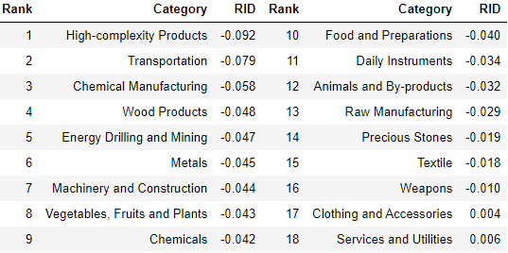
Table 2: Realized Industry Development (RID) of China (2018)

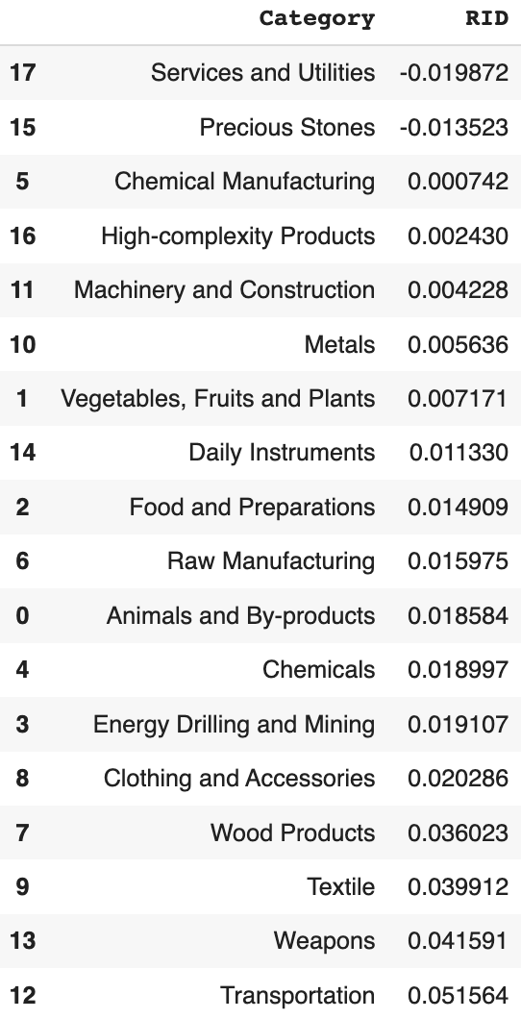
Table 3: Realized Industry Development (RID) of China (2021)

Between 2013 and 2018, China showed advancement in only 2 industries, with negative RIDs for the other industries. However, in 2021, China developed all industries except for 2. Despite making progress in developing almost all industries, China had a negative ECI in 2021. This may seem counterintuitive, but we explore this contradiction in the next few sections where we development strategies.

3.3 Regional and Global Comparison
Table 4 and 5 below summarize how the production strategy adopted by China compares with leading economies and a selected group of emerging economies in the world, as measured in RID. It can be directly observed that China focused on products with a higher complexity level, when compared against leading economies such as the United States and Germany, which gave a considerable level of attention to more advanced product groups such as clothing, services and utilities, and chemical manufacturing.

Ranking | France | the UK | Germany
1 | High-complexity Products | Services and Utilities | High-complexity Products
2 | Chemical Manufacturing | Weapons | Transportation
3 | Daily Instruments | Raw Manufacturing | Wood Products
4 | Animals and By-products | Precious Stones | Metals
5 | Food and Preparations | Animals and By-products | Food and Preparations
Table 4a: RID Comparison across Leading Economies (2018)

Ranking | France | the UK | Germany
1 | Services and Utilities | Precious Stones | Daily Instruments
2 | Precious Stones | High-complexity Products | Transportation
3 | High-complexity Products | Services and Utilities | Chemicals
4 | Energy Drilling and Mining | Energy Drilling and Mining | Chemical Manufacturing
5 | Machinery and Construction | Wood Products | Clothing and Accessories
Table 4b: RID Comparison across Leading Economies (2021)

Ranking | China | South Korea | Singapore
1 | High-complexity Products | Transportation | Transportation
2 | Transportation | Textile | High-complexity Products
3 | Machinery and Construction | High-complexity Products | Precious Stones
4 | Energy Drilling and Mining | Chemical Manufacturing | Daily Instruments
5 | Daily Instruments | Machinery and Construction | Services and Utilities
Table 5a: RID Comparison across Emerging Economies (2018)

Ranking | China | South Korea | Singapore
1 | Chemicals | Chemicals | Weapons
2 | Daily Instruments | Daily Instruments | Energy Drilling and Mining
3 | Transportation | Transportation | Transportation
4 | Raw Manufacturing | Textile | Machinery and Construction
5 | Weapons | Raw Manufacturing | High-complexity Products
Table 5b: RID Comparison across Emerging Economies (2021)

Table 5a and 5b further examine China’s development strategy against those of emerging economies on a global scale. Reasonably, emerging economies such as China, South Korea, Singapore and India have devoted the majority of their efforts into intermediate industry groups while developed economies such as France should have relied more on advanced industry groups. This trend holds true in general, regardless of the continent or the time period, and serves as an indicator for which phase of development a country is currently in as evaluated from its production strategy. Based on this standard, China is indeed adopting an efficient strategy that seeks development in industry groups with a higher level of complexity than it should.

4. Product Space Design

4.1 Suggested Development Vector
As aforementioned, distance gives us an idea of how far each new product is from a country’s current mix of exports. As defined in Hausmann and Hidalgo (2009), distance is “the weighted proportion of products connected to goods p that country c is not exporting, i.e., MCP=0.” Based on this definition, the distance between a country and any product that the country is currently exporting (i.e., the country is a significant exporter in the product as compared to global average) is zero. Similarly, opportunity gain quantifies the contribution of a new product in terms of opening up the doors to more and more complex products. Intuitively, a product that a country is currently exporting (i.e., MCP=1) has an opportunity gain of zero. And unreasonable investment on certain product p would lead to a relative decrement in export of more profitable products, and therefore lead to a negative opportunity gain of product p. The opportunity gain is not the only estimator of a country’s level of economic development. However, among countries with comparable economics strength, those having higher ECI, or in other words, more reasonable economics structure are often in better shape.

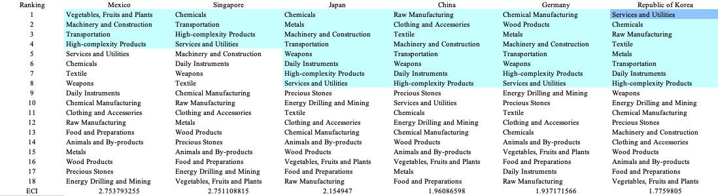

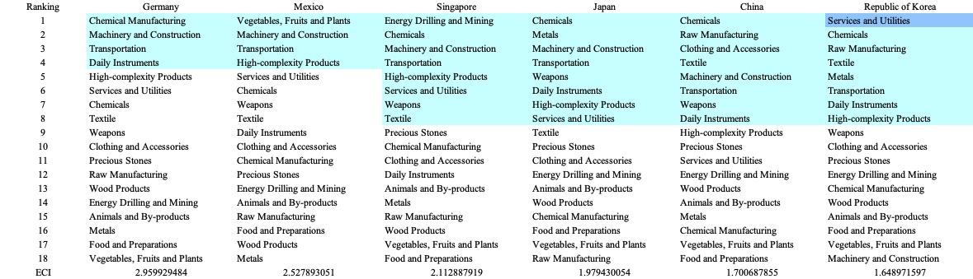
Table 6: SDV of High ECI Countries 2013(up), 2018(down)

We define the ranking of opportunity gain for a country c, as the Suggested Development Vector (SDV) of c. Table 6 shows the SDV of a selected group of leading economies with outstanding economic complexity, with the industry groups ranked in decreasing order of significance. Dark blue indicates positive opportunity gain, light blue indicates zero opportunity gains, and white indicates negative opportunity gains. The result shows that leading countries barely have any industries with positive opportunity gain. In other words, those countries are already in the most stable and efficient economic structure. Without the necessity of economic transition, those countries merely need to maintain a steady and balanced economic development. In contrast, countries listed in Table 7 have nearly half of industries with positive opportunity gain. While the economies with absolute negative ECI, such as South Africa and Colombia, all need to develop High-complexity Products, Machinery and Construction and Daily Instruments, those with median ECI are facing a more complicated and diverse situation, such as Italy and Spain.

It can be concluded that China is categorized to be a highly complex country as compared with the world’s leading economies and other major economies in Europe.

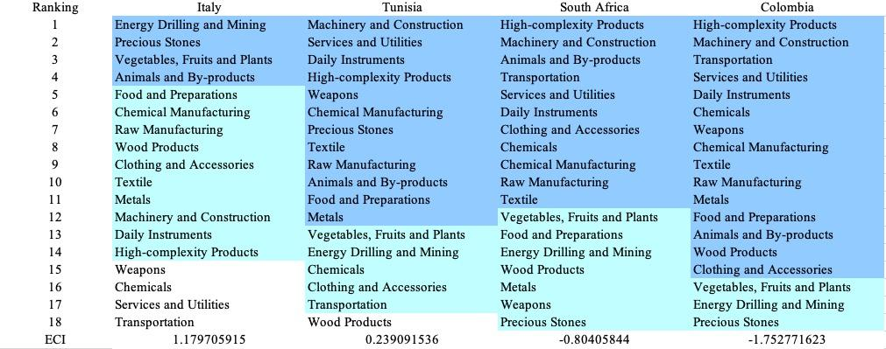

Table 7: SDV of Other Typical Countries 2013

4.2 Budgeted Industry Development Strategy and Interpretation

The optimal budgeted industry development strategy aims to solve the most efficient allocations under the budgeted constraint of different situations of heuristic total export growth. In order to obtain such an allocation portfolio, we formulate an optimization problem as the following:



where k(x) is the second largest eigenvector of $M_{CC'}$ after adding $x$ to the original export vector, C is the country that we are interested in, P is the product space, B is the heuristic budget.

If we can solve this problem, then we can know what the largest ECI that a country can improve to. Accordingly, the optimal solution $x*$ that we obtain here is exactly our optimal allocation. However, the biggest problem is that the objective function is not convex. Therefore, we cannot apply the classical tools for convex optimization on this problem. In order to solve this problem, our idea is to use greedy algorithm. The way that we apply greedy algorithm is that firstly we separate the total budget into k equal parts, and then for the first equal part we try to search for the product that can optimize our objective function by iterating through each $p∈P$. After we find the optimal product p for this equal part, we add the amount back to the export value of this product p and update the ECI for this country. If we observe that ECI does not change after iterating all the products, then we can add up one more equal part to invest. Until we find there is an ECI increment, we add the amount now to that product. The rest equal parts can be done in the same way.

However, as is known to all, greedy algorithm is a kind of local search algorithm, which is pretty possible to run into a local minimum. Therefore, for local search algorithms, one typical way is to keep it away from the local minimum is to enhance the vision of the algorithm by looking more steps forward. In our setting, whenever we obtain an increment of ECI, we mark down the required amount of export growth. Simultaneously, we continue searching for the next ECI increment point, compare the ratios of these two possibilities and pick the largest one. The ratio is defined as the following:


where ${ECI}_{p}$ is just the ECI of the country after adding some amount of export increment to product $p$, which is exactly the amount that is able to make ECI change. Also, we can express it in the way of $||$$x_{p}-x_{0}$${||}_{1}$.

In this way, we can obtain a further sighted greedy algorithm. Also, the number of parts that we would like to separate the budget into also matters. In order to solve this problem, we added a stabilizer on top of the enhanced greedy algorithm, by running the algorithm for different number of parts and selecting the portfolio with the largest ECI increment and most complex economic structure.

Besides, it is quite common that there is a surplus for the budget. To deal with the surplus, we just add it to the product which needs the least amount of dollar to make $M_{cp}$ = 1, (i.e., the smallest amount of required export increase).

Interpretation:
For the purpose of a clear explanation of the line charts, we try to label all the products in Table 8. Please refer to this table when trying to understand the investment trajectories in the line charts.

Label | Product Names
1 | Animal and By-products
2 | Vegetables, Fruits and Plants
3 | Food and Preparations
4 | Energy Drilling and Mining
5 | Chemicals
6 | Chemical Manufacturing
7 | Raw Manufacturing
8 | Wood Products
9 | Clothing and Accessories
10 | Textile
11 | Metals
12 | Machinery and Construction
13 | Transportation
14 | Weapons
15 | Daily Instruments
16 | Precious Stones
17 | High-complexity Products
18 | Services and Utilities

Table 8: Products Labeling

Below is the economic panel for China in 2013, we can see that for different percentages of heuristic total export growth, the ECI of China will have a different amount of increments. From the first two pie charts, we can see that ECI does not increase a lot. Also the budget is basically scattering into some basic industries, for example textile. However, for 15 percentage growth and 20 percentage growth, we can see that the slope of increment of ECI becomes greater and greater. This adequately explains the rapid development of China between 2009 and 2014. The green part of the pie chart denotes the product of machinery and construction. For the case of 15 percentage growth and 20 percentage growth, many of the increments in the line graph are caused by continuous investment in machinery and construction, which is exactly the industry that China relied most on during the rapid development.

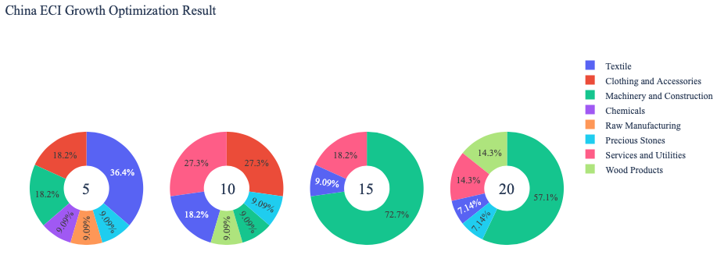

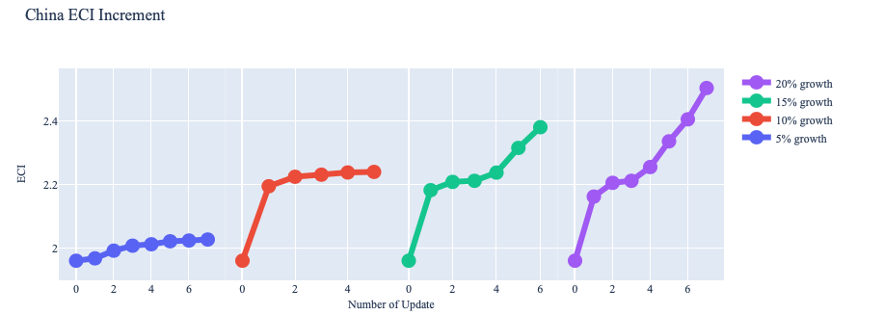
Figure 7: Greedy-Based ECI Improvement Results of China in 2013 with Different Budgets

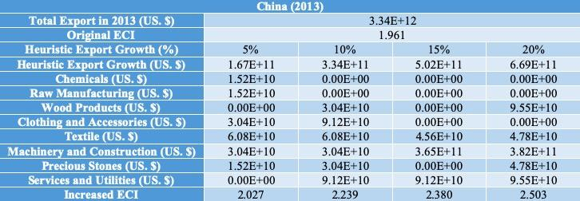
Table 10: Portfolio of China in 2013

For further suggestions on China’s development in the future, we also offer the optimization result of China based on China’s export data in 2018. Below is the economic panel for China in 2018, we can see that for different percentages of heuristic total export growth, the ECI of China will have a different amount of increments. Different from the situation of 2013, we can see that for 5 percent total export growth, China is already able to have great increment in ECI by developing mostly services and utilities, as well as textile. For the rest of the three pie charts, it shows that even though China can still earn increments in ECI by further developing machinery and construction, the effect becomes gradually diminishing, but it is still one of the directions for great development. Therefore, we suggest under the budget of 5 percentage or more export growth, focusing on developing machinery, services and textile can optimize the development.

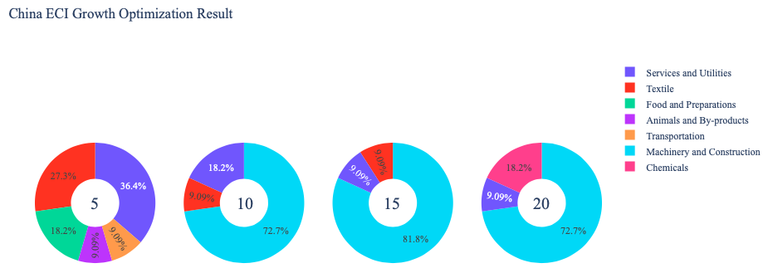
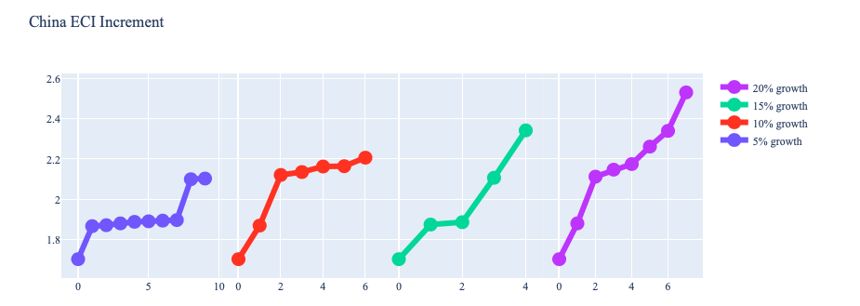
Figure 8: Greedy-Based ECI Improvement Results of China in 2018 with Different Budgets

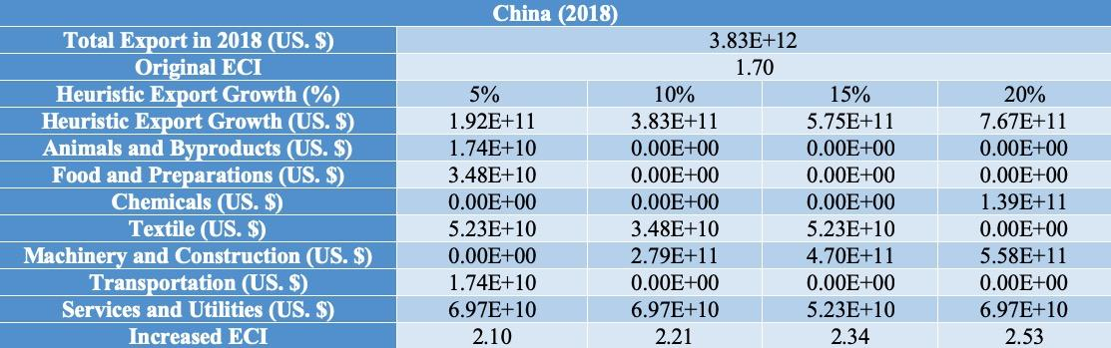
Table 11: Portfolio of China in 2018

Below is the economic panel for China in 2019, we can see that for different percentages of heuristic total export growth, the ECI of China would reach similar levels. The most critical industry in 5%, 10%, and 15% was Machinery and Construction, which is consistent with our recommendation from 2018. However, China did not focus on Machinery and Construction, as demonstrated by its RID, instead it developed other less productive industries. As a result, its ECI decreased during the 2019-2021 time period despite advancing almost all industries.

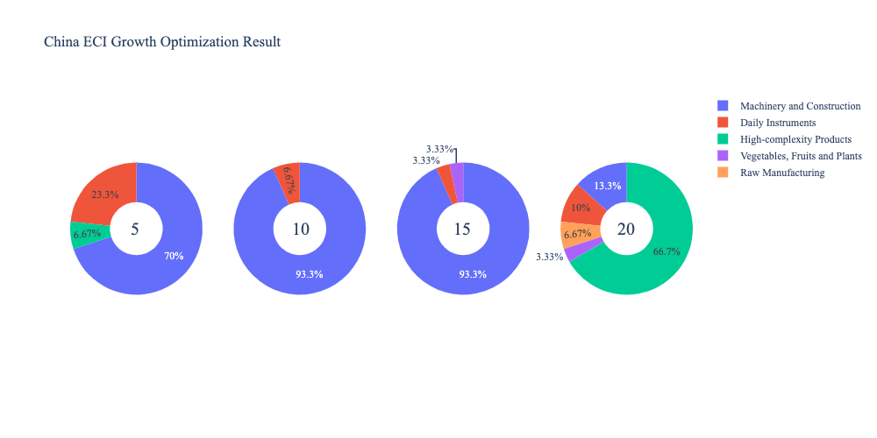
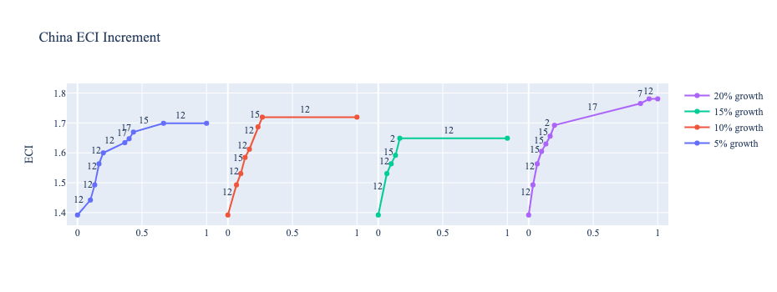
Figure 9: Greedy-Based ECI Improvement Results of China in 2019 with Different Budgets
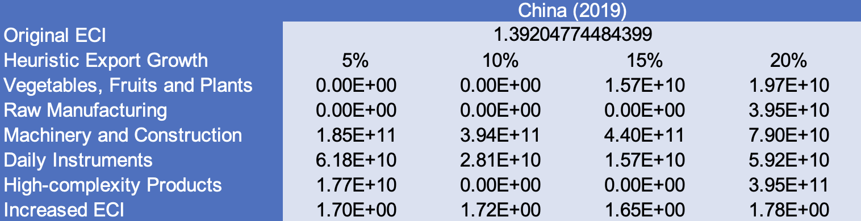
Table 12: Portfolio of China in 2019

For further suggestions on China’s development in the future, we also offer the optimization result of China based on China’s export data in 2021. Below is the economic panel for China in 2021, we can see that for different percentages of heuristic total export growth, the ECI of China will have a different amount of increments. Different from the situation of 2019, we can see that for 5 percent total export growth, China can achieve limited improvements in ECI. Again, Machinery and Construction remains the most vital industry, accounting for the greatest share of 5%, 10%, and 15% and increasing with greater percentages. However, if China can support 20% heuristic total export growth, it should consider developing high-complexity products which will yield an even larger ECI. Overall, we suggest under the budget of focusing on Machinery and Construction, followed by Daily Instruments.

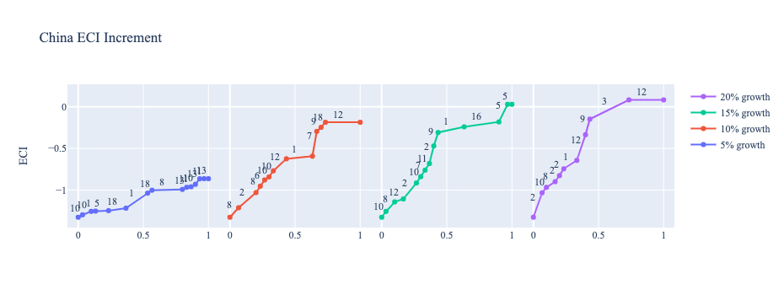
Figure 10: Greedy-Based ECI Improvement Results of China in 2021 with Different Budgets
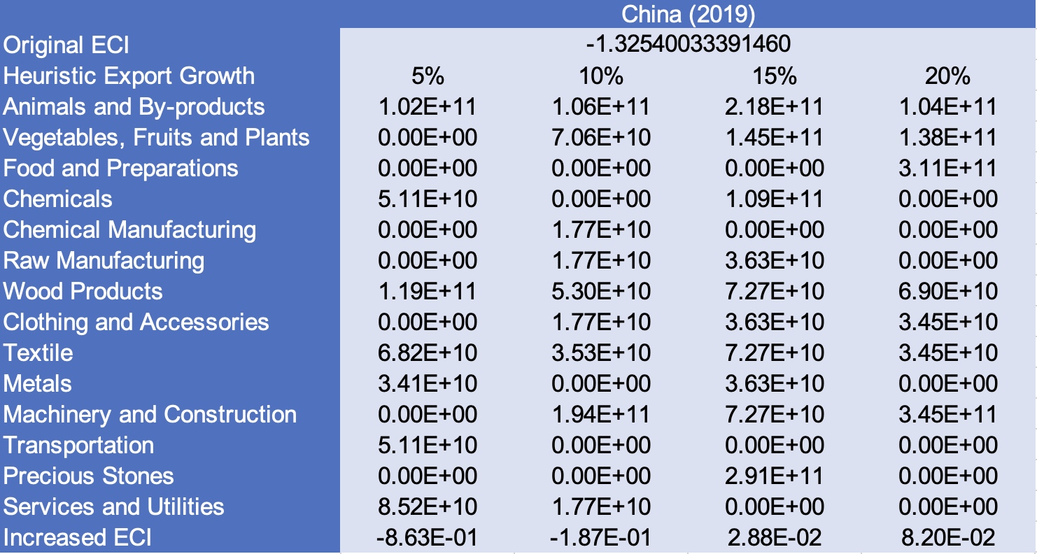
Table 13: Portfolio of China in 2021
4.3 Sensitivity Analysis and Contingency Strategy
In the following section our broad aim is to understand how sensitive China is to changes in export in various industries. While the Economic Complexity Index has been shown to contain valuable information about the economic strength/capacity of a country, little has been said as to the stability of the measure itself. We seek to uncover the main drivers of stability under a country's ECI score and better understand longer-term projections for ECI growth. Additionally, gaining an intuition on the industries that are bolstering an economy and the industries that offer the greatest return per unit of investment is best done through visualization of industry specific sensitivity. To this end, we have developed two categories of sensitivity analysis.
ECI Sensitivity Graph
Firstly, in order to assess the effect particular industries have on each respective country, we developed ECI Sensitivity graphs. We use shocking methodology to increment or decrement an industry’s export level by a certain percentage and recalculate the ECI all else being equal. While freezing the export dynamics of the rest of the world and enacting an instantaneous shock in export for a particular industry and country may not reflect real-life dynamics, what it does offer us is an understanding of a country’s level of dependency on an industry in the context of ECI. The shocking is done in small percentage increments in order to smooth out the resulting curve. Additionally, a recurring theme one will see is that for most industries, a breaking point occurs where the ECI either jumps upwards or downwards, creating a hockey stick shape rather than a linear trend. While the inflection point may not be accurate in context of real life, comparing the various inflection points across industries can give us valuable insight.
The graphs are formulated as follows: There are four ECI Sensitivity graphs. The first two represent data from 2018. The first chart shows positive shocking in which export numbers are shocked upwards per industry. The X-axis is in terms of percentage shock per current dollar value of export. The Y-axis is the recalculated ECI level post-shocking. The second chart follows the same format except the X-axis represents negative shocking. In other words, exports for each industry are decremented and the ECI is accordingly recomputed. The final two sensitivity graphs show the same results using 2013 data. Below is an example of an ECI sensitivity graph.

Figure 11: Example 2018 (Incremental ECI Sensitivity)

SDV sensitivity
Secondly, we analyze the sensitivity of the SDV to changes in export levels. The goal is to understand how export level changes for a particular industry can affect the marginal opportunity gain for other industries. We will be using specifically High Complexity Products and Food and Preparations as our base industries. We will be increasing or decreasing the absolute export level in both of these industries and observing the effects on the SDV.
When the opportunity gain of an industry is negative, the SDV sensitivity approximates how an over-development of the industry jeopardizes the economic structure of a country. When the opportunity gain of the industry is zero, the SDV sensitivity determines whether the further development of the industry shapes the country with a better economic structure and predicts how the SDV would change accordingly. Specifically, as we reduce the export of such an industry to 25%-50% of its original value, a few other industries originally with negative opportunity gain could likely become profitable.
Similar to the ECI sensitivity graphs above, we will be shocking export of High Complexity Products and Food and Preparations in small percentage increments. A new SDV, represented by a new column in the charts, is recorded only when a certain level of shock changes the structure of the SDV. In effect we are incrementing or decrementing export levels of two industries until the marginal opportunity gain of any industry changes in category (positive, negative, or neutral). Below is an example of a SDV Sensitivity chart with Positive Shocking. Industries with positive marginal opportunity gain are colored blue, neutral is colored white and negative is colored red.

Table 14: Example High-complexity Products 2018 (Incremental SDV Sensitivity)

Contingency Plan
The Contingency Plan aims to present a set of solutions with respect to upheavals in different industries. Instead of compensating for the declining production directly, the best strategy is to develop those incipiently profitable industries. In this manner, we can derive the contingency strategy for countries to deal with possible abrupt declines of crucial industries. In some cases, the SDV remains unchanged even when a zero-opportunity-gain industry declines to its 20% in terms of export. We can then conclude the industry is not indispensable to the country. As a clarification, the three consecutive N/As means that the country doesn’t even need to respond to a collapse in the industry. Countries tend to have distinct solutions to the up and down of the same industry. To create the contingency strategy table we decrease the export level for each industry in the country’s current production space by 60% respectively. The three highest ranking industries in the new SDV are then returned.


Table 15: Example Contingency Strategy 2018

4.3 Sensitivity Analysis Results and Interpretation

Below is China’s 2018 ECI Sensitivity Charts. Firstly in the positive chart, we notice immediately that a small increase in High Complexity Product export levels immediately increases ECI. To this end, investing in High complexity types of products will serve China the most in the shorter term. Interestingly increases of exports in machinery can lead to even higher ECI increases than high complexity products but only after doubling of machine exports. Other industries such as Transportation and Daily instruments also lead to significant increases in ECI.

Next we consider China’s 2018 Negative Shock chart. We can see that the same industries such as Machinery, High complexity products, and Transportation all drastically lower ECI if export are shocked downwards. This is expected since China performs well in these particular industries relative to other countries worldwide. One also notices that decreasing exports in Raw-Manufacturing and Chemicals increases ECI so it may be beneficial to lower resources to those industries and allocate those resources to industries such as Transportation.

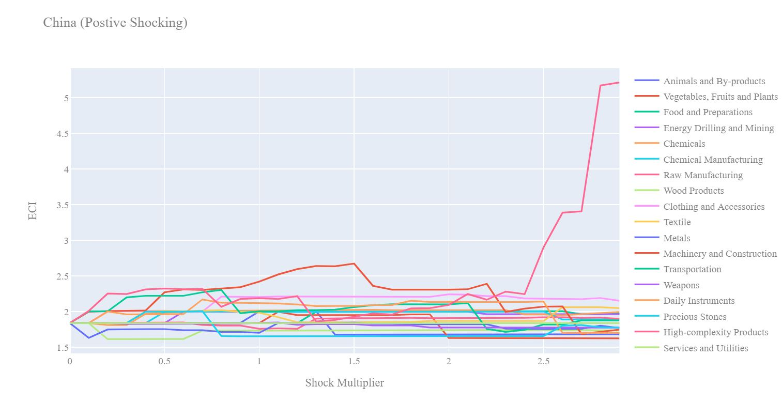
Figure 12: China 2018 (Incremental ECI Sensitivity)
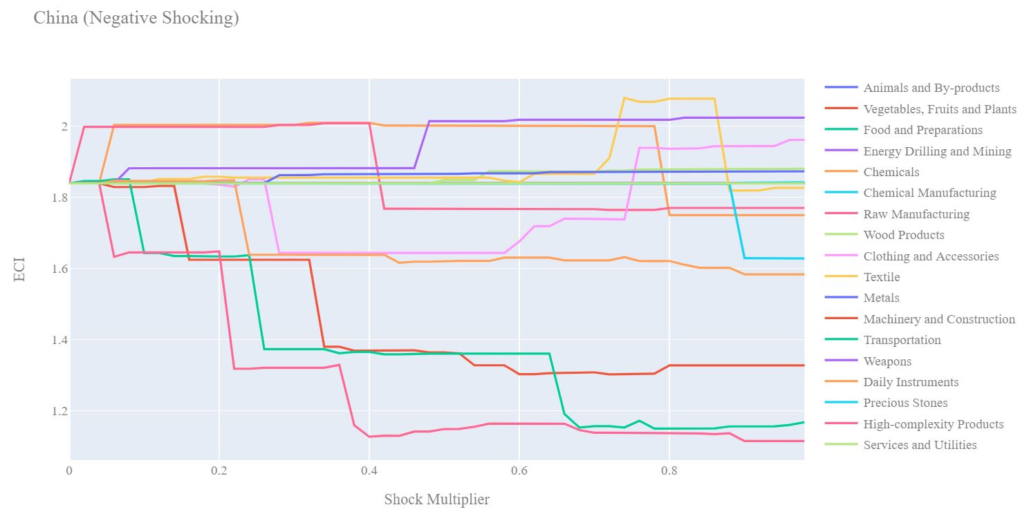
Figure 13: China 2018 (Decremental ECI Sensitivity)

Next we consider the 2013 ECI Sensitivity graphs. We see that in the positive shocking case, the landscape of ECI sensitivity has not altered significantly over the five year period. In the shorter term there are quite a few more industries than in 2018 that have the potential to improve ECI. High Complexity Products, Daily Instrument, Transportation, and Machinery all seem to improve ECI similarly with around a 25% increase in export although Machinery seems to outperform after large increases in export levels.

In the 2013 negative shocking case, we see that again China is very sensitive to drawbacks in its three major export areas of High Complexity Products, Transportation, and Machinery however unlike the 2018 case, we see a lot less sensitivity to Daily Instrument and Clothing and Accessories. China has likely become more economically dependent on those two industries over the five year period.
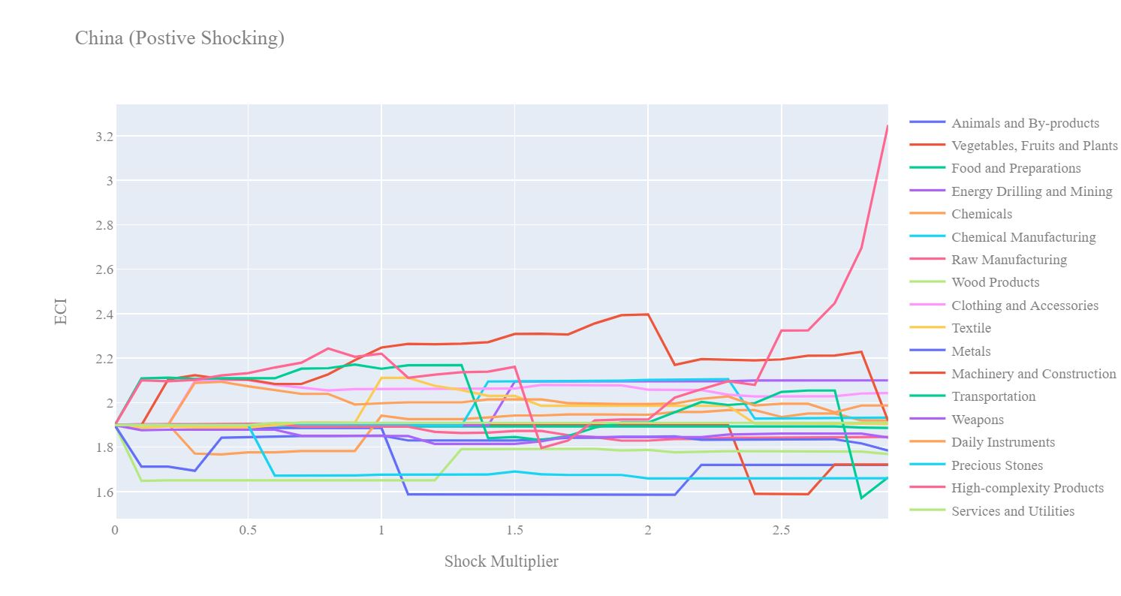
Figure 14: China 2013 (Incremental ECI Sensitivity)

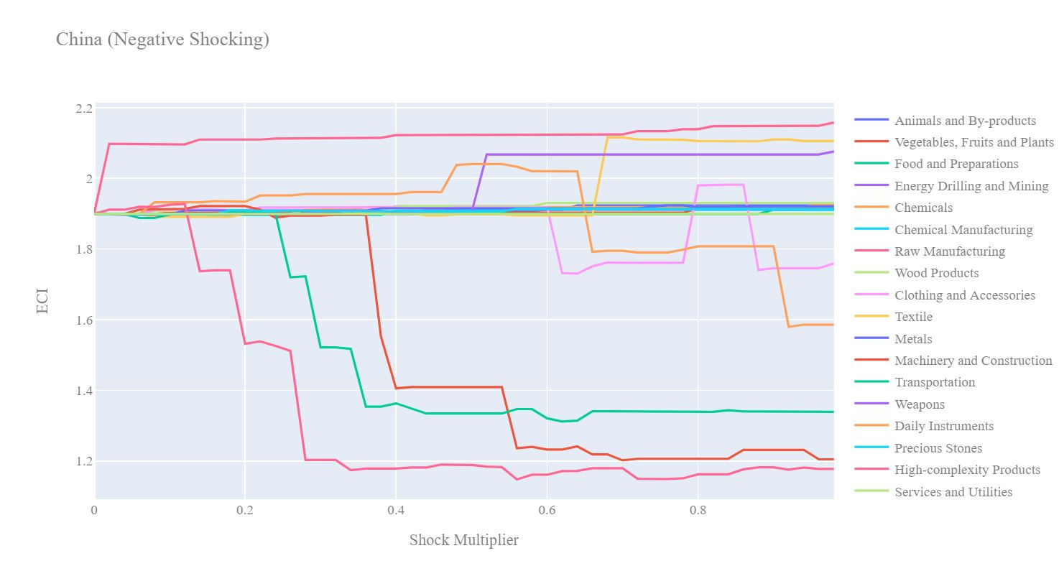
Figure 15: China 2013 (Decremental ECI Sensitivity)

Below we see the SDV sensitivity charts for High Complexity Products in 2018. China’s SDV is quite insensitive to increases in High Complexity products. Only after 130% increase in export we start to see other industries shift into the positive marginal opportunity gain area. Since High Complexity products reduce China’s distance to other complex products, the gain the country can experience in other complex industries such as Machinery or Transpiration increases with the increase of High Complexity product exports.

Considering the Negative SDV sensitivity chart we observe that since China is a leader in other staple industries, the decrement of High Complexity Product export does not affect the SDV of China at all. We only see the switching of industries from the negative opportunity gain territory to the neutral opportunity gain territory. This means the decrease in Japan’s ECI over the course of the pandemic was independent of the development of high-complexity products and should be attributed to other reasons, such as mismatched focus on Machinery and Construction.

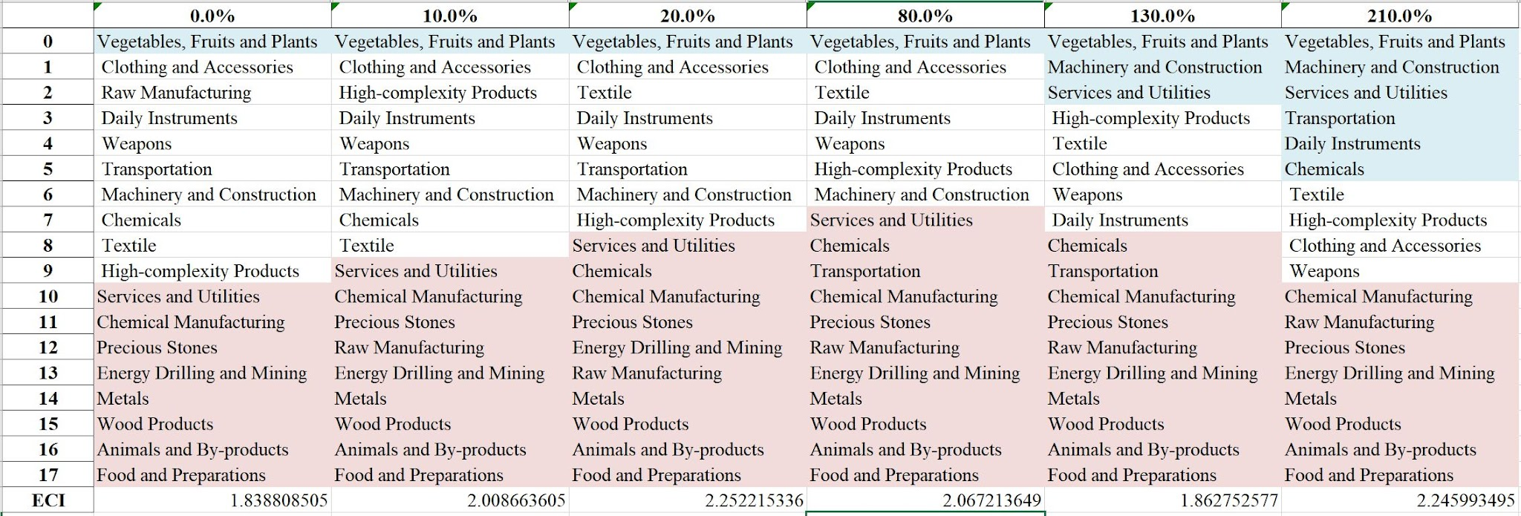
Table 16: China High-complexity Products 2018 (Incremental SDV Sensitivity)

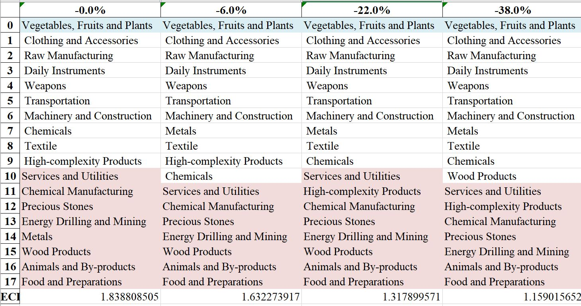
Table 17: China High-complexity Products 2018 (Decremental SDV Sensitivity)

China has a characteristic SDV of high-complexity economy and is embedded with massive production knowledge. China should take precautions against unexpected strikes industry by industry and forecast the adverse effects. In summary, High-complexity Products exerts great impacts on the economic structure of top countries. Such countries are extremely vulnerable to High-complexity Products industry declines, and benefit from High-complexity Products prosperity. In contrast, ECI is not highly sensitive to shifts in the Food and Preparations industry.

We observe a similar pattern that the Sensitivity Score of Food and Preparations is approximately zero, while the Decremental Sensitivity Score is larger than the Increment. We can therefore make three conclusions here.
- The disturbance in the Food and Preparations industry exert a trivial impact on the ECI of a country, which echoes with our intuition that Food and Preparations is of minimal significance to the structure of product space of developed countries or fast developing countries.
- The High-complexity Products industry is the cornerstone industry of most developed or fast developing countries.
- The reward of an increase of High-complexity Products production is less than the jeopardy of a decrease in the same extent.

4.4 Contingency Strategy
Decreasing export of each industry in China’s 2018 production space by 60% respectively, we derive the contingency strategy shown below.

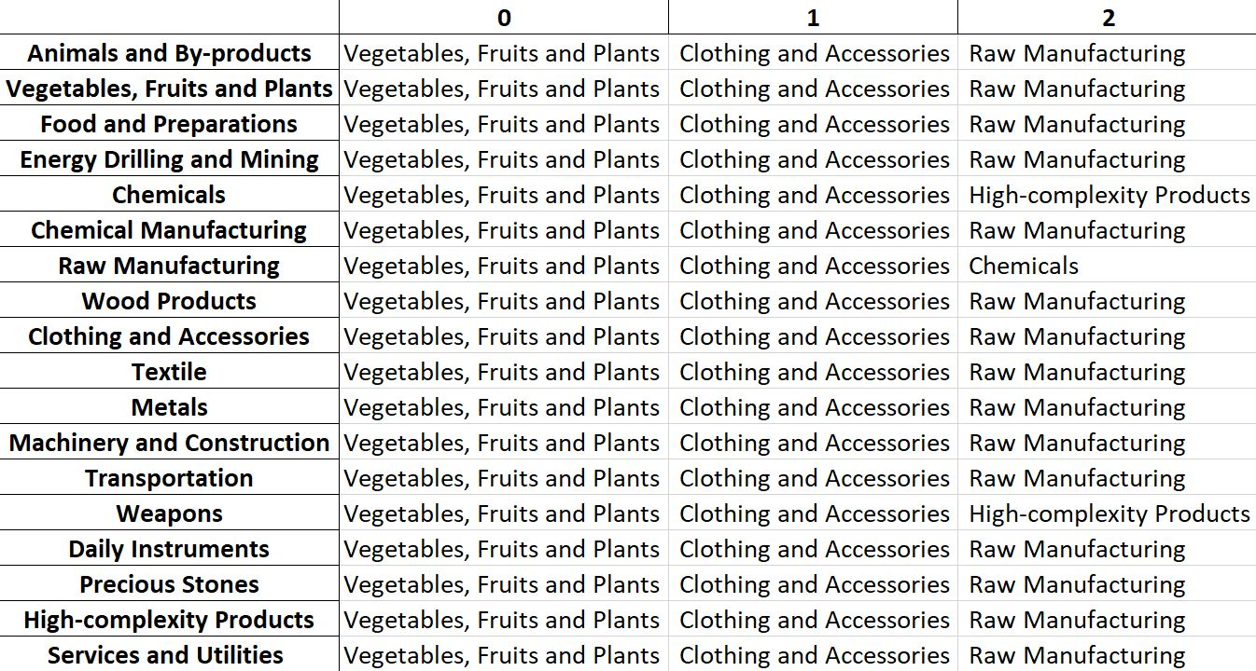
Table 22: China Contingency Strategy 2018

Based on China’s RID for 2021, we note that the contingency strategy recommended by our algorithm in 2018 was aligned by China’s development strategy over the course of the pandemic since Vegetables, Fruits and Plants, Clothing and Accessories, and Raw Manufacturing all had positive RIDs. As such, it supports the reasoning behind China’s increase in GDP between 2019 and 2021.

5. Macro-level Predictions

5.1 Structural Optimality Index
Indeed, such choice of prioritization has proven to be a significant factor in deciding the economic outcomes of countries. In order to quantitatively evaluate how effective our development strategies are and how deviations from the suggested developmental path will lead to suboptimal growth results, we define the measure – Structural Optimality Index (SOI) – on a country level as the Adjusted R-Square obtained from regressing the country’s realized industry development over the suggested development strategy. Both strategies are quantified in nature, with the realized development represented by export increase in every major industry groups and the suggested development strategy represented by the opportunity gains of developing the corresponding industry groups as calculated in previous sections. The adjusted R-square from the regression thus provides us with a quantified measure of how the development path adopted by the country has fitted with/differed from calculations on a complexity level.

After obtaining this measure for all countries in our database, we further regress countries’ five-year economic growth, which is defined as the percent increase in GDP (USD), over their SOI. Figure 6 illustrates the regression output, which shows a strong positive correlation between countries’ SOI and their five-year GDP growth, significant at the 1% level and achieving an adjusted R² of 4.5%. In other words, the more a country develops as suggested by calculations on a complexity level, the better economic outcomes it achieves.

Table 18: OLS Regression Results
Dep. Variable: GDP | F-Statistic: 5.963
R²: 0.054 | Prob (F-Stat): 0.0163
Adj R²: 0.045 | No. Observations: 106


Figure 19: Regression of Five-year GDP Growth over SOI

5.2 SOI of China and Its Implications
As the regression in Figure 20 suggests (the orange curve represents export increase and the blue curve stands for opportunity gain of the corresponding industry), China demonstrates a high level of correlation with the suggested developmental path, having an adjusted R-square of around 16.75% in 2013-2018. China ranks the 31st place among all countries in terms of SOI and ranks the 4th place in terms of its economic growth from 2013 to 2018, which is consistent with the regression result in Figure 6. This is in direct contrast to developed economies such as Japan, where there is moderate SOI of around -4.8% and a corresponding 5-year growth rate of 9.0%, ranking it a slow-developing economy during the period. In sum, China’s amazing economic progress from 2013 to 2018 can be at least partially explained by a nearly optimal development strategy that demonstrates a considerable level of matches with our suggested developmental path.

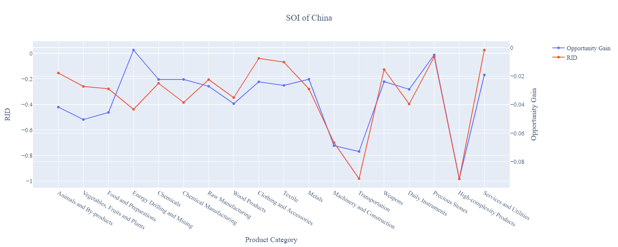

Figure 20: SOI of China (2013-2018)

In 2021, China demonstrated a moderate level of correlation with the suggested developmental path, having an adjusted R-square of around 4.51%. While China’s GDP increased between 2019-2021, this change can be attributed to developing almost all of its industry; however, it did not develop key industries such as Machinery and Construction so its ECI decreased. Consequently, it experienced a lower average GDP growth rate which is consistent with the lower adjusted R-square score.

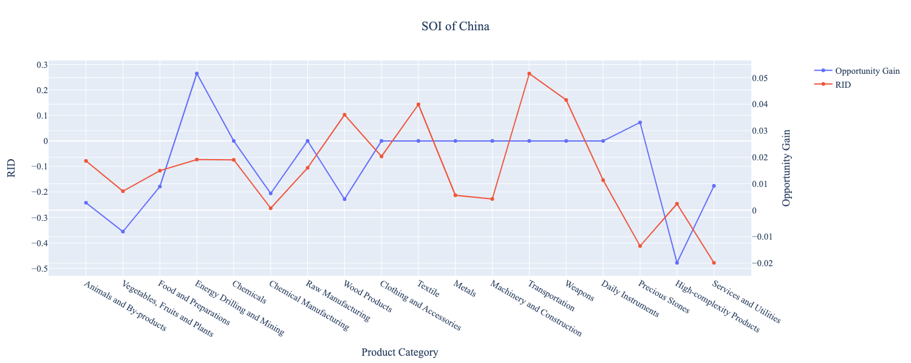

Figure 21: SOI of China (2019-2021)

6. Concluding Remarks

In conclusion, China has demonstrated a surprising level of economic growth in terms of GDP during the period from 2013 to 2018, concurrent with an upsurge in economic complexity as compared with other major Asian or emerging economies in the world. From 2019-2021, China continued its GDP growth, with a slight stagnation in 2020 due to the pandemic, while its ECI decreased, much like other developed economies.

The amazing progress made during the period, we believe, can be largely explained through analysis of the economic and product complexity structure of China on the industry group level. The product classification system we adopt allows us to measure the realized industry development for various industry groups and to observe that China strategically invested in developing High-complexity Products, Transportation, and Machinery and Construction industries during the period, while its Asian counterparts and emerging economies around the globe have adopted much more conservative growth paths. While China’s Machinery and Construction industry did advance in 2019-2021, there is significant room for improvement in terms of ECI with an even greater focus on that industry. Instead, China chose to develop almost all its industries, focusing on others that do not contribute as much to the ECI, but this resulted in a higher GDP.

Based on our analysis of the opportunity gain and a sensitivity analysis of major industry groups, China did not further its gains by staying optimal with its current industry structure prior to the pandemic and there was no immediate need for reform because no industry has a positive opportunity gain at its current stage. Given the economic effects of COVID-19, we observe that China should refocus on Machinery and Construction in order to improve its ECI. We further note that China had a well-matched development strategy in 2013-2018 that indicated a high level of fitness with the strategy calculated on a complexity level, having an adjusted R-square of around 16.8%. As this R-square value decreased to 4.51% in 2019-2021, China had mismatched, though effective, development strategy. Since a significant positive correlation exists between five-year GDP growth and the structural optimality index of an economy as we define and calculate, China adopted an favorable development plan as compared with other emerging economies both on a regional scale and on a global scale, although it has potential to further leverage its economic gains through industrial structure optimization as suggested in the paper.

References

Hausmann, R., Hidalgo, C., Bustos, S., Coscia, M., Chung, S., Jimenez, J., Simoes, A. and Yıldırım, M. (2007). The Atlas of Economic Complexity. [online] Atlas.cid.harvard.edu. Available at: http://atlas.cid.harvard.edu/.

Balassa, B., “The Purchasing Power Parity Doctrine - A Reapprais- al,” Journal of Political Economy 72, 584-596 (1964).

Feenstra, R.; Lipsey, R.; Deng, H.; Ma, A. & Mo, H. “World Trade Flows: 1962-2000” NBER working paper 11040. National Bureau of Economic Research, Cambridge MA (2005).

United Nations Commodity Trade Statistics Database (http://comtrade.un.org/db/), accessed in August 2019.

The World Economic Forum, “The global competitiveness report,” (various years).

Barro, R. & Lee, J-W. “A New Data Set of Educational Attainment in the World, 1950-2010,” NBER Working Paper No. 1590 (2010).

Kaufmann, D. & Kraay, A. “Governance Indicators: Where Are We, Where Should We Be Going?” Policy Research Working Paper 4370. Washington, DC: World Bank (2008).

Hanushek, E.A. & Woessmann, L. “The Role of Cognitive Skills in Economic Development,” Journal of Economic Literature 46(3), 607- 668 (2008).

